190905104
Parth Shukla

1)

#include <cuda.h>
#include <stdlib.h>
#include <stdio.h>
// block size as N
__global__ void vecAddKernel_1a(float *A, float *B, float *C)
{
int idx = threadIdx.x + blockIdx.x * blockDim.x;
C[idx] = A[idx] + B[idx];
}
// N threads within a block
__global__ void vecAddKernel_1b(float *A, float *B, float *C)
{
int idx = threadIdx.x + blockIdx.x * blockDim.x;
C[idx] = A[idx] + B[idx];
}
// Keep the number of threads per block as 256 (constant) and vary the number of blocks to handle N elements.
__global__ void vecAddKernel_1c(float *A, float *B, float *C,
int n)
{
int idx = threadIdx.x + blockIdx.x * blockDim.x;
if (idx < n)
{
C[idx] = A[idx] + B[idx];
}
}
void vecAdd(float *A, float *B, float *C, int n)
{
int size = n * sizeof(float);
float *d_A;
float *d_B;
float *d_C;
cudaMalloc((void **)&d_A, size);
cudaMalloc((void **)&d_B, size);
cudaMalloc((void **)&d_C, size);
cudaMemcpy(d_A, A, size, cudaMemcpyHostToDevice);
cudaMemcpy(d_B, B, size, cudaMemcpyHostToDevice);
printf("A: ");
for (int i = 0; i < n; i++)
{
printf("%f, ", A[i]);
}
printf("\n");
printf("B: ");
for (int i = 0; i < n; i++)
{
printf("%f, ", B[i]);
}
printf("\n\n");
vecAddKernel_1a<<<n, 1>>>(d_A, d_B, d_C);
cudaMemcpy(C, d_C, size, cudaMemcpyDeviceToHost);
printf("A+B (from 1a kernel): ");
for (int i = 0; i < n; i++)
{
printf("%f, ", C[i]);
}
printf("\n");
vecAddKernel_1b<<<1, n>>>(d_A, d_B, d_C);
cudaMemcpy(C, d_C, size, cudaMemcpyDeviceToHost);
printf("A+B (from 1b kernel): ");
for (int i = 0; i < n; i++)
{
printf("%f, ", C[i]);
}
printf("\n");
vecAddKernel_1c<<<ceil(n / 256.0), n>>>(d_A, d_B,
d_C, n);
cudaMemcpy(C, d_C, size, cudaMemcpyDeviceToHost);
printf("A+B (from 1c kernel): ");
for (int i = 0; i < n; i++)
{
printf("%f, ", C[i]);
}
printf("\n");
cudaFree(d_A);
cudaFree(d_B);
cudaFree(d_C);
}
int main()
{
float *h_A, *h_B, *h_C;
int n = 5;
int size = n * sizeof(float);
h_A = (float *)malloc(size);
h_B = (float *)malloc(size);
h_C = (float *)malloc(size);
for (int i = 0; i < n; i++)
{
h_A[i] = (i + 1) * 10;
h_B[i] = i + 1;
}
vecAdd(h_A, h_B, h_C, n);
return 0;
}
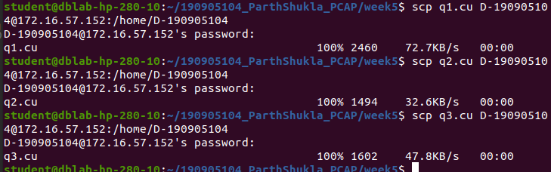

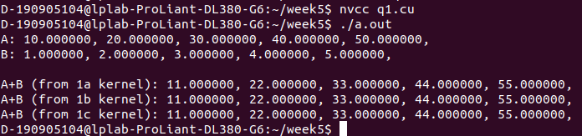

2)

#include <cuda.h>
#include <stdlib.h>
#include <stdio.h>
__global__ void
selectionsortkernel(float *A, float *B, int n)
{
int idx = threadIdx.x + blockIdx.x * blockDim.x;
float key = A[idx];
int pos = 0;

for (int i = 0; i < n; i++)
{
if (A[i] < key || (A[i] == key && i < idx))
{
pos++;
}
}
B[pos] = key;
}

void selsort(float *A, float *B, int n)
{
int size = n * sizeof(float);
float *d_unsorted_arr;
float *d_sorted_arr;

cudaMalloc((void **)&d_unsorted_arr, size);
cudaMalloc((void **)&d_sorted_arr, size);

cudaMemcpy(d_unsorted_arr, A, size, cudaMemcpyHostToDevice);

selectionsortkernel<<<1, n>>>(d_unsorted_arr, d_sorted_arr, n);
cudaMemcpy(B, d_sorted_arr, size, cudaMemcpyDeviceToHost);

cudaFree(d_unsorted_arr);
cudaFree(d_sorted_arr);
}

int main()
{
float *h_unsorted_arr, *h_sorted_arr;
int n = 5;
int size = n * sizeof(float);
h_unsorted_arr = (float *)malloc(size);
h_sorted_arr = (float *)malloc(size);
for (int i = 0; i < 5; i++)
{
scanf("%f", &h_unsorted_arr[i]);
}
selsort(h_unsorted_arr, h_sorted_arr, n);
printf("unsorted_arr: ");
for (int i = 0; i < n; i++)
{
printf("%f, ", h_sorted_arr[i]);
}
printf("\n\n");
printf("sorted_arr: ");
for (int i = 0; i < n; i++)
{
printf("%f, ", h_sorted_arr[i]);
}
printf("\n");
return 0;
}

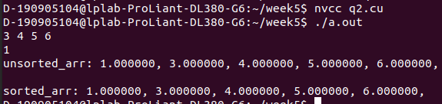

3)
#include <cuda.h>
#include <stdlib.h>
#include <stdio.h>
__global__ void
oddEven(float *arr, int n)
{
int idx = threadIdx.x + blockIdx.x * blockDim.x;
if (idx % 2 == 1 && idx + 1 < n)
{
if (arr[idx] > arr[idx + 1])
{
float temp = arr[idx];
arr[idx] = arr[idx + 1];
arr[idx + 1] = temp;
}
}
}
__global__ void evenOdd(float *arr, int n)
{
int idx = threadIdx.x + blockIdx.x * blockDim.x;
if (idx % 2 == 0 && idx + 1 < n)
{
if (arr[idx] > arr[idx + 1])
{
float temp = arr[idx];
arr[idx] = arr[idx + 1];
arr[idx + 1] = temp;
}
}
}
void oddEvenTranspositionSort(float *arr, int n)
{
int size = n * sizeof(float);
float *d_arr;
cudaMalloc((void **)&d_arr, size);
cudaMemcpy(d_arr, arr, size, cudaMemcpyHostToDevice);
for (int i = 0; i <= n / 2; i++)
{
oddEven<<<1, n>>>(d_arr, n);
evenOdd<<<1, n>>>(d_arr, n);
}
cudaMemcpy(arr, d_arr, size, cudaMemcpyDeviceToHost);
cudaFree(d_arr);
}
int main()
{
float *h_arr;
int n = 5;
int size = n * sizeof(float);
h_arr = (float *)malloc(size);
for (int i = 0; i < 5; i++)
{
// h_arr[i] = rand() % 50;
scanf("%f", &h_arr[i]);
}
printf("unsorted_arr: ");
for (int i = 0; i < n; i++)
{
printf("%f, ", h_arr[i]);
}
printf("\n\n");
oddEvenTranspositionSort(h_arr, n);
printf("sorted_arr: ");
for (int i = 0; i < n; i++)
{
printf("%f, ", h_arr[i]);
}
printf("\n");
return 0;
}

